Music development plan summary:
Woodlands Academy

Overview
Detail | Information
Academic year that this summary covers | 2025-2026
Date this summary was published | 11.12.2025
Date this summary will be reviewed | 30.09.2026
Name of the school music lead | Kirsty Stansfield
Name of school leadership team member with responsibility for music (if different) | Alistair Rea
Name of local music hub | Nottingham Music Hub

This is a summary of how our school delivers music education to all our pupils across three areas – curriculum music, co-curricular provision and musical experiences – and what changes we are planning in future years. This summary forms the second year of our Music Development plan. This information is to help pupils and parents or carers understand what our school offers and who we work with to support our pupils’ music education.

Curriculum: Music
This is about what we teach in lesson time, how much time is spent teaching music and any music qualifications or awards that pupils can achieve.
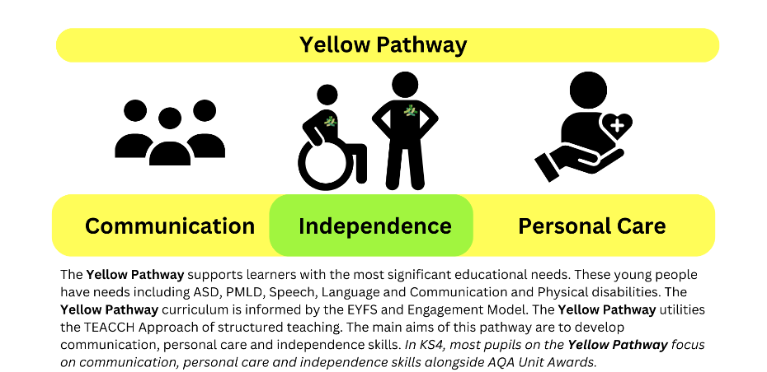
Pupils in KS2-KS4 on the Yellow Pathway access music as part of their sensory curriculum offer, both in discrete timetabled sessions and as an ongoing and embedded part of their daily learning encounters. Music is used in communication-focused lessons and activities. with singing and instruments used to support pupils’ skills, knowledge and understanding around pace, tempo, greetings, turn-taking and independence. Cross-curricular links are also made between teaching and learning of environmental and musical sounds in phonics and music. Pupils are assessed against the Engagement Model on the Yellow Pathway.
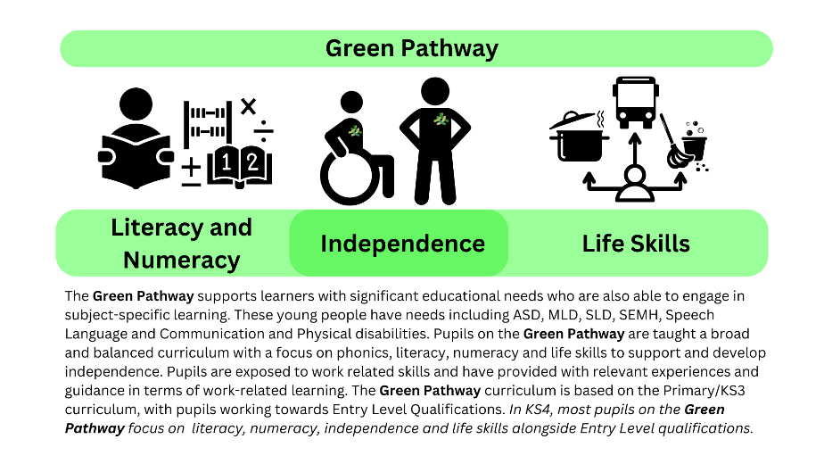
Pupils in KS2 and KS3 of our Green Pathway have two timetabled lessons of music per week as part of their curriculum offer. One of these lessons is taught by a music specialist from Nottingham Music Hub, the focus of these lessons is becoming familiar with, and learning to play, musical instruments, whilst working towards participating in an ensemble performance. These lessons are sequential and tailored to the bespoke needs of individual classes and pupils. The other timetabled lesson focuses on active listening, with pupils experiencing music from a range of artists and styles from traditional and historical to the present day. These active lessons allow pupils to learn and revisit a breadth of music terminology, in line with the National Curriculum, and encourage pupils to express their emotional responses and preferences. Pupils are assessed against the National Curriculum on the Green Pathway. Pupils in KS4 of our Green Pathway have one timetabled lesson of music per week as part of their curriculum offer. This lesson focuses on active listening, with pupils experiencing music from a range of artists and styles from traditional and historical to the present day.
Through all of our learning pathways, Music is used during key transitions, either from one activity to another, or from one learning environment for another. Classes are encourage to access a ‘minute of listening’ once a week as part of their tutor time.

Extra Curricula Music
This is about opportunities for pupils to sing and play music, outside of lesson time, including choirs, ensembles and bands, and how pupils can make progress in music beyond the core curriculum.
Pupils access a range of instruments as part of their Music lessons and experiences at Woodlands Academy. One-to-one musical instrument tuition is not currently offered due to the community aspect of music at Woodlands.
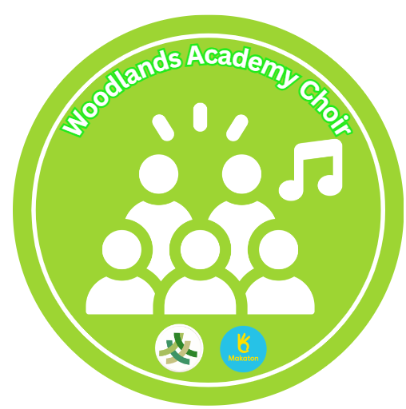
Pupils across all three learning pathways are encouraged to join the Woodlands Choir which combines singing and Makaton signing. Our Woodlands Choir meet once a week (and a little more often in the build up to Christmas), with pupil voice playing a key part in the songs and signs that pupils learn and subsequently preform. Our Choir perform at internal and external events.

Musical performances
This is about all the other musical events and opportunities that we organise, such as singing in assembly, concerts and shows, and trips to professional concerts.
Pupils have the opportunity to sing and perform in front of parents, carers, staff, guests and the community at:
- A Taste of Woodlands
- The Christmas Fair
- The Summer Fair
- Weekly assemblies
- Christmas in the City Concerts
We are always exploring widening opportunities for our pupils to perform, such as on educational visits within the local and wider community (such as pantomimes and choir performances).

In the future
This is about what the school is planning for subsequent years.
Woodlands Academy increased the number of music lessons for pupils on the Green Pathway for the academic year 2025-2026, with one lesson having a theory-based approach to music, focusing on active listening.
Woodlands Academy has updated is methods of assessment for music, creating a further connected assessment approach between Nottingham Music Hub and Woodlands Academy, alongside the Engagement Model for pupils on the Yellow Pathway.
Woodlands Academy is also looking to develop closer ties with the local community and other educational settings, with a view to Woodlands’ pupils singing, signing and playing in other venues and at a range of events. This also includes looking towards pupils developing their knowledge and understanding of careers in the music or creative industry and educational visits of live performances.
Woodlands Academy is looking towards further tailoring its music curriculum towards individual pupils’ interests, whilst also considering appropriate music resources for this delivery in future academic years.

Further information
Useful links for Pupils, Parents, Carers and Staff:
The Department for Education Guide: guide for parents and young people
Nottingham Music Hub: Home | Nottingham Music Hub
Minute of Listening: Home - Minute of Listening

Arts Council Posters:
